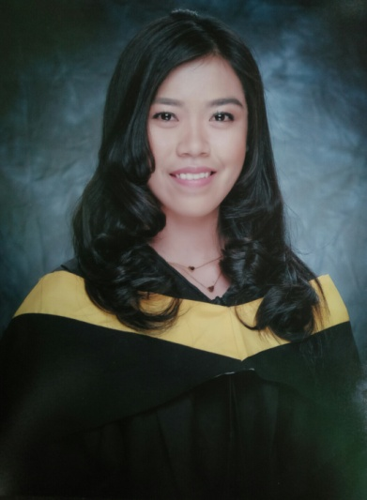**AZELLENE SAN AGUSTIN FRANCISCO** #0319 Lambakin, Marilao, Bulacan +639269711571 [franciscoazellene@gmail.com](mailto:franciscoazellene@gmail.com)

­­­­­­­

**OBJECTIVES:hjghjgjghjgjhghghjgghjgjggggggggggggggggggggggggggggggggggggggvvgggggggggg**

To become a performing and contributing individual of a continuously developing industry where knowledge are highly advocated and credited.

**PRACTICAL EXPERIENCE: hjghjgjghjgjhghghjgghjgjgggggg gggggggggggggggjmhmhggggggggggg**

**2Go Travel / Oceanlink Institute Inc.**

**Position:** On the job training (200 Hours)February 01, 2017 - February 08, 2017

Front Desk Agent/ Receptionist

On Board - M/V St. Francis Xavier

**Resorts World Manila**

**Position:** Usherette January 15, 2017 - February 28, 2017

Newport Blvd, Pasay, Metro Manila

**Trip Galore Travel and Tours**

**Position:** On the job training (200 Hours) November 09, 2016 – December 27, 2016

Ticketing Reservationist ( Meralco Village Lias Marilao, Bulacan

**Mc Donald’s Company**

**Position:** Service Crew (SPES) April 18, 2016- June 10, 2016

SM City Marilao; Ibayo Marilao, Bulacan

**EDUCATIONAL BACKGROUND:hjghjgjghjgjhghg hjgghjgjggggggggggggggghjhjjhhjhhhh**

**Tertiary: Bachelor of Science in Tourism Management**

Pambayang Dalubhasaan ng Marilao 2013-2017

Abangan Norte, Marilao, Bulacan

*Achievement:* **Deans Lister**

Two Consecutive Semesters

College of Tourism Management

**Secondary:** A.F.G Bernardino Memorial Trade School 2009-2013

Lias, Marilao, Bulacan

**SKILLS and QUALIFICTIONS : hj jgjghjgjhghg hjgghjgjggggggggggggggghjhjjh**

* Honest and loyal towards work.
* Continuously learn, develop and improve.
* Highly competent, Self-motivated, and hardworking with the ability to rapidly learn and apply new skills.
* Computer literate (MS Word, Excel, Power Point, Internet application)

**SEMINARS AND TRAININGS ATTENDED: hjghjgjghjgjhghghjgghjg jgggggggggggggggggggggggg**

* Basic Training (SOLAS)

North Star Training INC. (Cabuyao, Laguna)

May 17-23 2017

* Events in an Event: Furnishing Key Aspects towards Successful Events Management

Multi - Purpose Hall (Pambayang Dalubhasaan ng Marilao)

October 13, 2016

* Act, Talk and Walk “A Career Path Seminar”

Audio Visual Room (Pambayang Dalubhasaan ng Marilao)

July 20, 2016

* Achieving service excellence creates a customer focus to Airline Industry Success

Audio Visual Room (Pambayang Dalubhasaan ng Marilao)

February 12, 2015

* Building an exceptional Professional Images and A social Etiquette Seminar

Audio Visual Room (Pambayang Dalubhasaan ng Marilao)

July 12, 2014

**PERSONAL INFORMANTION:hjghjgjghjgjhghghjgghjgjgggggggggggggggggggggggggggggggggggg**

DATE OF BIRTH: March 25, 1997

MARITAL STATUS: Single

GENDER: Female

RELIGION: Roman Catholic

CITIZENSHIP: Filipino

LANGUAGE: English, Tagalog, Basic Nihongo and French

**CHARACTER REFERENCE: hjghjgjghjgjhghghjgghjgjggggggggggggggggggggggggggggggggghjkkk**

* Mrs. Joan Valerie Javier College Dean of Hospitality and Tourism Management (PDM)

09428702090

* Mr. Adriel Alcantara

General Manager

Trip Galore Travel and Tours

09268283089

I hereby certify that the above information *is true and correct to the best of my knowledge.*

______________________________

**AZELLENE SAN AGUSTIN FRANCISCO**